Exploring Jenkins

* So let’s get started by installing Jenkins.(Link: <https://www.jenkins.io/doc/book/installing/>)
* Today we will be using a linux machine to install Jenkins which has ubuntu distribution
* This setup will be done on AWS with 2 vCPUs and 8 GB of RAM

Jenkins History 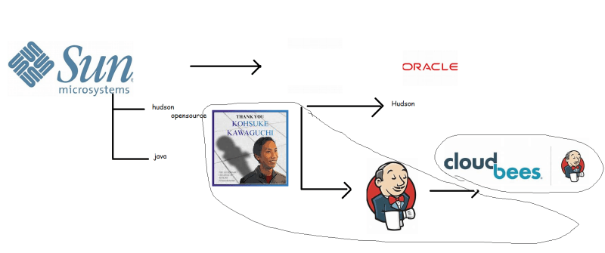

Installing Jenkins on Ubuntu 18.04:

* Login into the jenkins using ssh
* Lets see the list of users on the linux machine

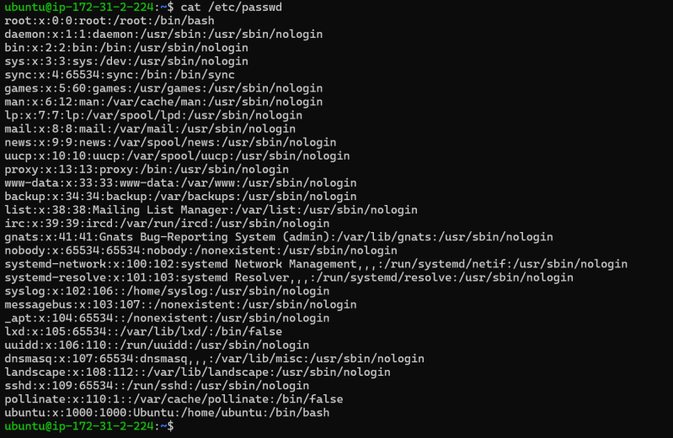

Let’s try to install java 11 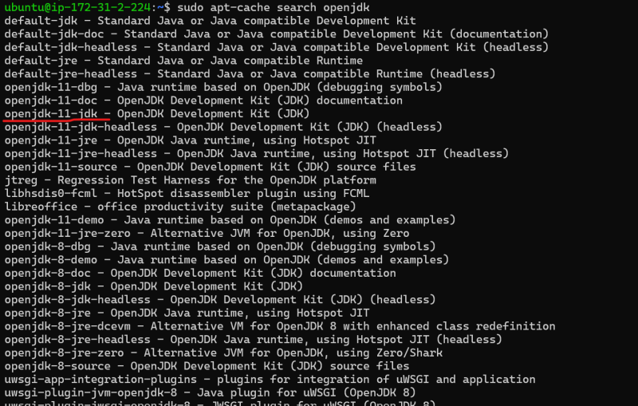

* + Install by executing the command sudo apt install openjdk-11-jdk -y
  + Install jenkins by executing the below commands
* sudo apt update
* wget -q -O - https://pkg.jenkins.io/debian-stable/jenkins.io.key | sudo apt-key add -
* sudo sh -c 'echo deb https://pkg.jenkins.io/debian-stable binary/ > \
* /etc/apt/sources.list.d/jenkins.list'
* sudo apt-get update
* sudo apt-get install jenkins

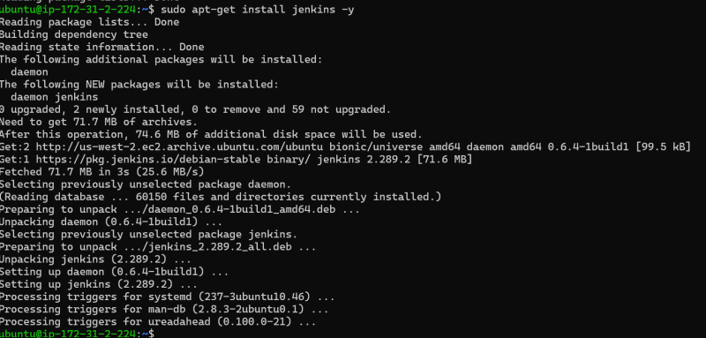

Now lets see the list of the users 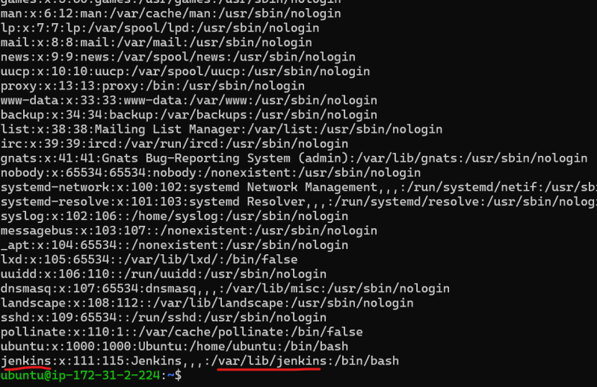

A New user called as jenkins is created and the home directory of this user is /var/lib/jenkins

Jenkins runs on port 8080 so navigate to http://<public-ip&gt;:8080

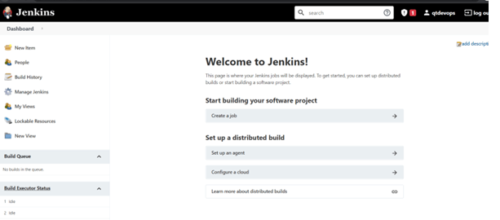

**Basic Jenkins Terminology**

* Project/Job: This is where we define the steps to be executed.

**Exploring & understanding**

Steps 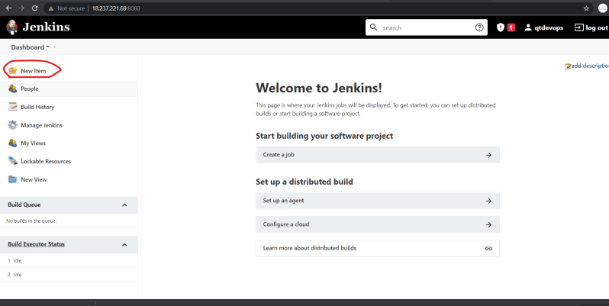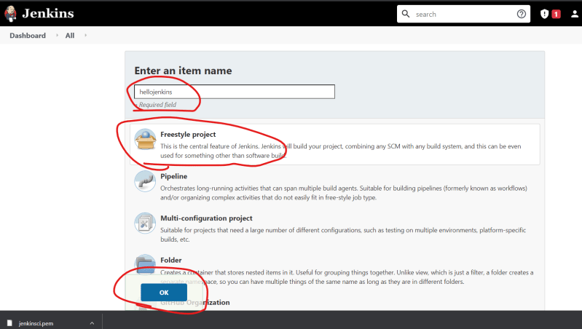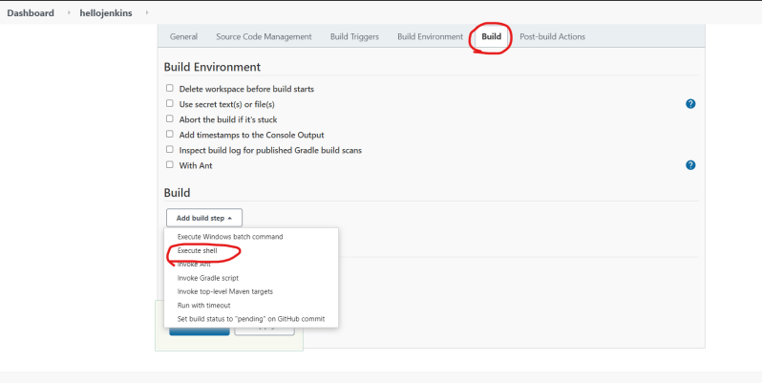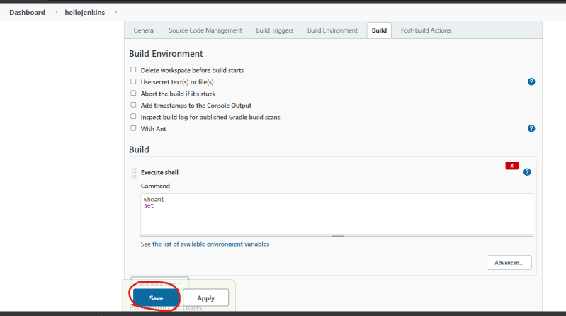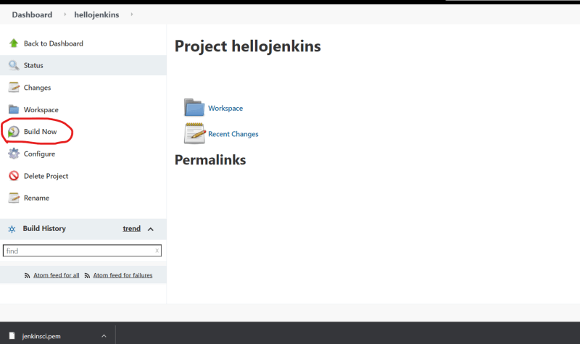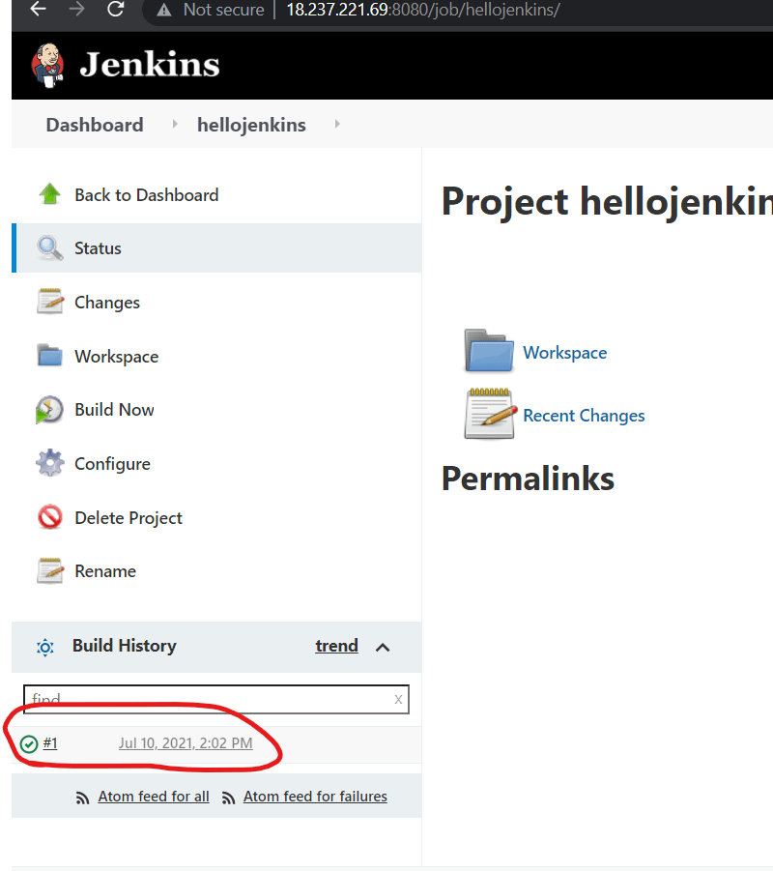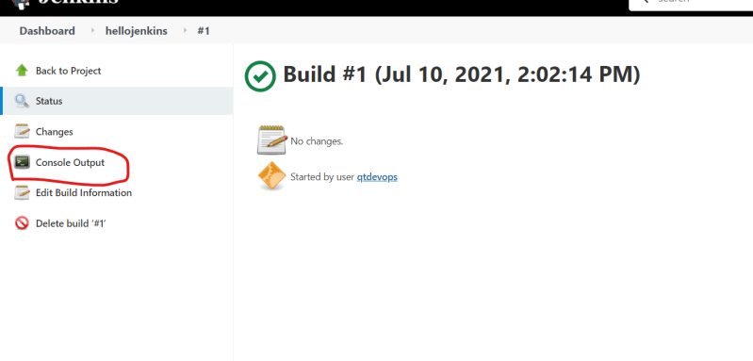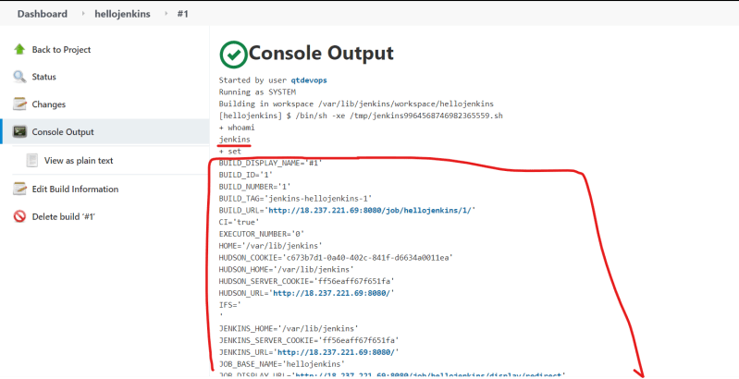

* When i run/build a project in jenkins it is running as a newly created jenkins user
* So jenkins is nothing but a scheduler which runs the linux commands as some linux user.
* To make the life simple, jenkins creates some ui components which are friendly towards building a project (CI/CD)

**Manual Scenario 1**

* Cloning the project from git. For this let’s take a project called as spring pet clinic (Link: https://github.com/spring-projects/spring-petclinic)
* To clone a project from git we require
  + git to be installed
  + probably internet connection
  + some disk space
* Create a Jenkins job and in the build step type git clone command.

**What is Jenkins Plugin**

* Let’s try to clone the spring pet clinic repository as mentioned above, Let’s look at git plugin 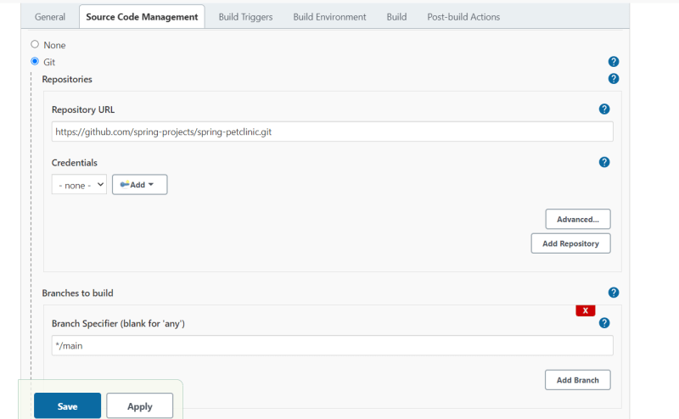
* plugin is a UI developed which will translate into low level commands. These UI will help in doing the job easily.

**Let’s try to build java 11 project**

* clone the git repository (Link: https://github.com/neiljbrown/java11-examples)and cd into java-11-projects then execute

mvn package

* To make this command work install maven

sudo apt install maven -y

* If we can execute the command manually on the linux machine it will work from jenkins as well.

**Let’s try to execute sudo commands from Jenkins**

* The commands to be executed are

sudo apt update

* Let’s create the Jenkins job 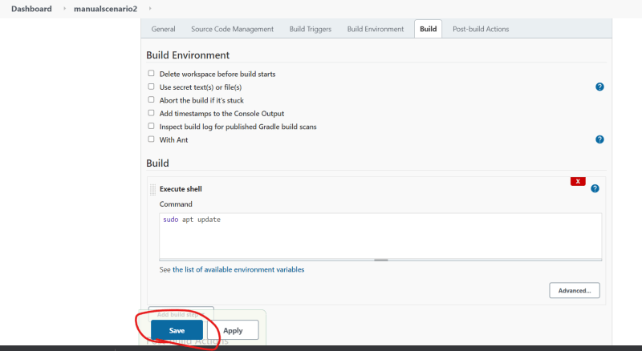
* The Status is 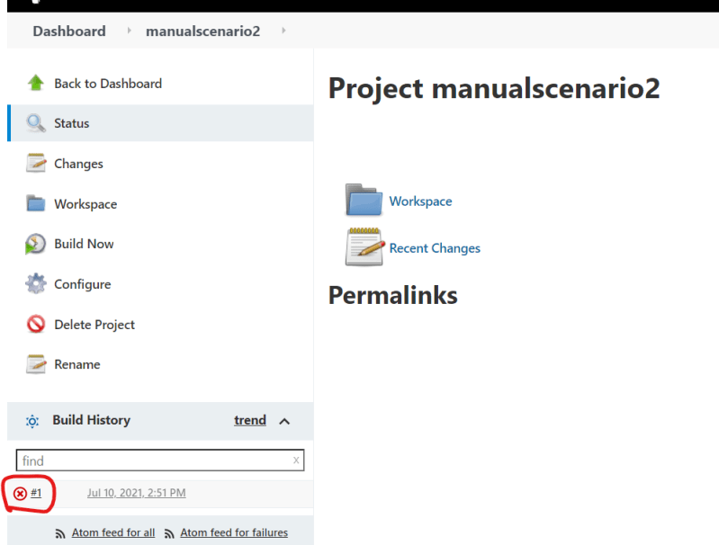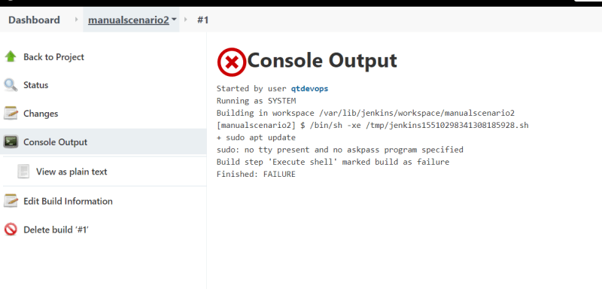
* Just because commands work on the system does not mean they will work from Jenkins. To evaluate whether they work or not we need to work with Jenkins user
* Now added Jenkins user to sudoers file with NOPASSWD option

Basic Mantra: Ensure that user has given necessary tools installed and permission to execute job.